HR Analysis Dashboard | Attrition, Performance & Employee Satisfaction

Author
Sulaimon Sikiru Oladele

Table of Contents
Author 1
Abstract 2
Dashboard 2
Project Overview 3
Business Questions 4
Objectives 5
Data Description 5
Methodology 5
Exploratory Data Analysis 6
Key Performance Indicators (KPIs) 8
Key Insights 8
Recommendations 9
Conclusion 10
Additional Dashboard Insight 10

Abstract
This project presents a comprehensive HR Analytics Dashboard developed using the IBM HR Analytics Employee Attrition & Performance Dataset to uncover the key drivers of employee attrition, performance, and compensation. The dashboard leverages Power BI to transform raw HR data into actionable insights that support strategic workforce planning and evidence-based decision-making. Through interactive visualizations, the analysis explores how demographic factors, job characteristics, overtime, commute distance, marital status, education level, and tenure influence employee turnover and performance outcomes. The findings highlight high-risk employee segments, compensation disparities, and performance trends, enabling organizations to design targeted retention strategies, improve employee satisfaction, and strengthen overall workforce stability. This project demonstrates advanced analytical capabilities in data modeling, DAX, visualization design, and HR insight storytelling.

Dashboard
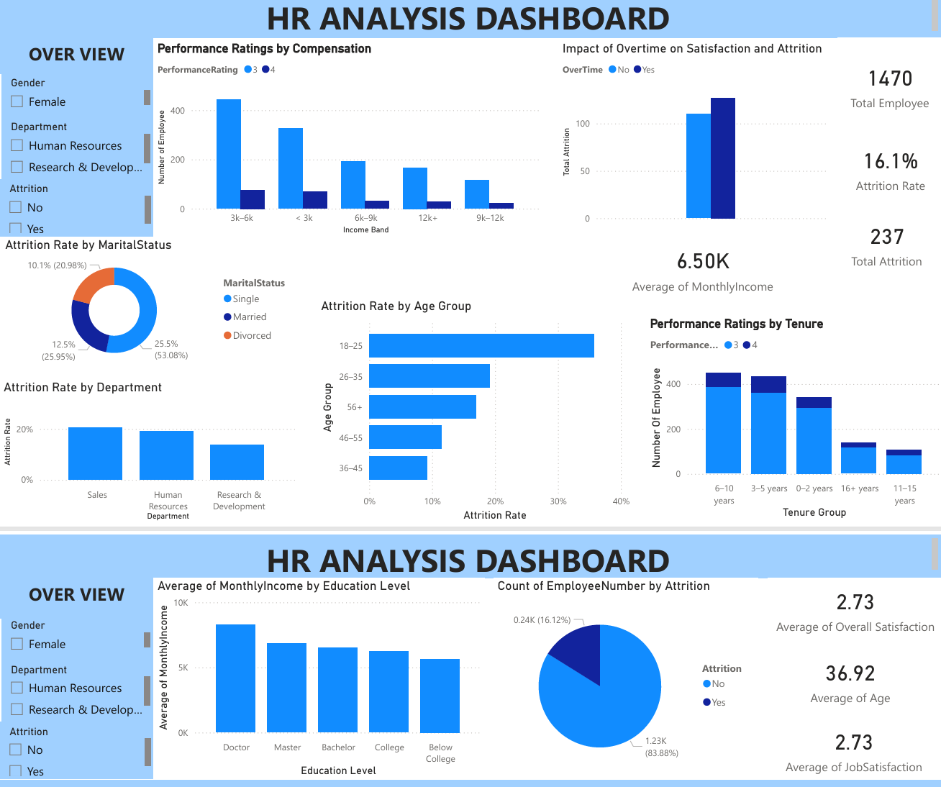

Project Overview
This HR Analytics Dashboard project provides a comprehensive, data-driven examination of workforce dynamics using the IBM HR Analytics Employee Attrition & Performance Dataset, a widely recognized benchmark dataset for studying employee turnover and performance behavior. The dataset contains rich, granular employee-level information, making it ideal for uncovering the key drivers of attrition, compensation patterns, performance trends, and demographic influences within an organization.
The primary goal of this project is to transform raw HR data into meaningful insights that support strategic decision-making. By leveraging Power BI’s advanced analytical and visualization capabilities, the dashboard integrates multiple dimensions of employee information—including demographics, job roles, compensation, performance ratings, satisfaction metrics, overtime behavior, and commute distance—to reveal patterns that influence employee retention and organizational stability.
This solution is designed for HR leaders, business managers, and executives who require a clear, intuitive, and interactive view of workforce trends. The dashboard enables users to:
- Identify high-risk employee groups and departments
- Detect early warning signs of attrition
- Understand how compensation and performance evolve over time
- Evaluate the impact of work-life balance factors such as overtime and commute distance
- Explore demographic influences such as age, marital status, and education level
- Support evidence-based HR planning, talent management, and retention strategies
The analysis is presented across two interactive dashboard pages:
Employee Attrition Overview
This page focuses on understanding who is leaving the organization and why. It highlights overall attrition levels, departmental turnover, demographic risk factors, and the influence of variables such as overtime, marital status, age group, and distance from home. Dynamic slicers allow users to drill down into specific employee segments and uncover targeted retention opportunities.
Performance & Compensation Analysis
This page explores how employee performance and compensation evolve over time. It examines the relationship between education level and income, the distribution of performance ratings, and how tenure influences both compensation and performance outcomes. This helps HR teams identify high-performing employees, evaluate pay equity, and understand how experience contributes to performance growth. Together, these dashboards provide a holistic, actionable view of the workforce. They empower the organization to make informed decisions that improve retention, enhance employee satisfaction, and strengthen overall workforce stability. The project demonstrates advanced Power BI capabilities, including data modeling, DAX calculations, interactive visual design, and insight-driven storytelling—showcasing the ability to convert complex HR data into strategic business intelligence.
At its core, the project aims to bridge the gap between raw HR data and actionable business insights. Modern organizations face increasing pressure to retain top talent, optimize workforce performance, and maintain a healthy organizational culture. However, without a structured analytical framework, HR teams often struggle to identify the root causes of turnover, understand compensation disparities, or evaluate how demographic and behavioral factors influence employee outcomes. This dashboard addresses these challenges by providing a comprehensive, visually intuitive platform that highlights the most critical workforce trends.
The dataset itself contains a rich blend of demographic attributes, job-related characteristics, compensation metrics, performance ratings, and work-life balance indicators. By integrating these variables into a cohesive analytical model, the dashboard enables users to explore how factors such as age, marital status, education level, overtime frequency, commute distance, job role, and tenure contribute to attrition risk and performance variability. The result is a multi-dimensional view of the workforce that goes far beyond surface-level reporting.

Business Questions
This project is designed to answer the following key HR questions:
- What is the overall employee attrition rate?
- Which departments and employee segments experience the highest attrition?
- How does overtime impact employee satisfaction and retention?
- Is there a relationship between education level and monthly income?
- How do performance ratings vary with tenure and compensation?
- Are certain age groups more likely to leave the organization?
- How does marital status impact employee attrition?
- How does distance from home affect attrition rates?

Objectives
Each business question is supported by a clear analytical objective:
- Measure the overall attrition rate to establish a baseline for workforce stability.
- Identify high-risk departments and employee segments to support targeted retention strategies.
- Analyze the impact of overtime on satisfaction, work-life balance, and attrition risk.
- Evaluate the relationship between education level and monthly income to assess pay fairness and career progression.
- Understand how performance ratings vary with tenure and compensation to support talent development and reward systems.
- Examine attrition patterns across age groups to identify vulnerable employee segments.
- Assess how marital status influences attrition to understand lifestyle-related turnover factors.
- Determine whether commute distance contributes to attrition and identify opportunities for flexible work arrangements.

Data Description
The project uses the IBM HR Analytics Employee Attrition & Performance Dataset, which includes:
- Demographics (age, gender, marital status)
- Job information (department, job role, job level)
- Compensation (monthly income, salary bands)
- Performance ratings
- Tenure and experience
- Work-life factors (overtime, distance from home, satisfaction scores)
- Attrition status

Methodology
Data Preparation
- Cleaned and validated dataset
- Created calculated columns (Age Groups, Distance Bands, Tenure Groups, Income Bands)
DAX Measures
- Attrition Rate
- Total Employees
- Total Employees Selected
- Satisfaction Metrics
- Performance Metrics
Dashboard Development
- Built interactive visuals
- Applied consistent color themes
- Added slicers for dynamic filtering
- Designed a clean, intuitive layout
Insight Extraction
- Identified patterns across demographics, compensation, and performance
- Compared high-risk vs low-risk employee groups
- Evaluated relationships between key variables

Exploratory Data Analysis
Employee Attrition Overview
Key visuals include:
- Overall Attrition Rate KPI
- Attrition by Department
- Attrition by Age Group
- Attrition by Distance from Home
- Attrition by Marital Status
- Overtime Impact on Attrition
- Slicers for Department, Job Role, Gender, Age Group, Education, etc.

Performance & Compensation Analysis
Key visuals include:
- Performance Rating Distribution
- Monthly Income by Education Level
- Performance Rating by Tenure Group
- Scatter Plot: Income vs Tenure
- Compensation Distribution
- Job Role vs Performance

KPI |  |  | Description |  |  | Value / Insight
Overall Attrition Rate |  |  | Percentage of employees who left the organization |  |  | 16%
Total Employees |  |  | Total number of employees in the dataset |  |  | 1,470 employees
Total Employees Who Left |  |  | Count of employees who attrited |  |  | 237 employees
Highest Attrition Department |  |  | Department with the highest turnover |  |  | Sales
Highest Attrition Segment |  |  | Employee segment with highest attrition |  |  | Single employees
Overtime Attrition Impact |  |  | Attrition difference between overtime vs non-overtime workers |  |  | Overtime employees attrit significantly more
Education vs Income Insight |  |  | Relationship between education level and monthly income |  |  | Higher education → higher income
Performance vs Tenure Insight |  |  | How performance changes with experience |  |  | Higher tenure → higher performance
Age Group With Highest Attrition |  |  | Age segment most likely to leave |  |  | 18–25 years
Distance From Home Impact |  |  | Attrition based on commute distance |  |  | 21+ miles → highest attrition

Key Performance Indicators (KPIs)

Key Insights
Attrition Insights
- Overall attrition rate is 16%.
- Sales and R&D show the highest turnover.
Employee Segmentation Insights
- Single employees show the highest attrition.
- Married employees have the lowest turnover.
Overtime & Satisfaction
- Overtime strongly correlates with higher attrition and lower satisfaction.
Education & Income
- Higher education levels lead to higher income.
Performance, Tenure & Compensation
- High performers cluster at higher income and longer tenure.
Age Group Attrition
- Employees aged 18–25 have the highest attrition.
Marital Status & Attrition
- Single employees are significantly more likely to leave.
Distance From Home & Attrition
- Employees living 21+ miles away show the highest attrition.

Recommendations
Improve retention in high-risk departments
- Conduct exit interviews
- Review workload and leadership issues
- Implement targeted retention programs
Address overtime-related burnout
- Introduce workload balancing
- Encourage flexible schedules
- Monitor overtime hours closely
Support younger employees
- Provide career development programs
- Offer mentorship
- Improve onboarding experience
Reduce long-distance commute stress
- Offer remote/hybrid work options
- Provide transportation support
Reward and retain high performers
- Implement performance-based incentives
- Create clear promotion pathways

Conclusion
This HR Analytics Dashboard provides a powerful, data-driven understanding of employee attrition, performance, and compensation using the IBM HR Analytics dataset. By identifying high-risk groups and uncovering key drivers of turnover, the organization can implement targeted strategies to improve retention, enhance employee satisfaction, and strengthen workforce stability.
This project demonstrates strong capabilities in:
- Power BI dashboard design
- DAX calculations
- Data modeling
- HR analytics
- Insight storytelling
A polished, professional portfolio piece showcasing your ability to turn HR data into actionable business intelligence.

Additional Dashboard Insight
